**ASSIGNMENTS ON DIGITAL MARKETING**

**NAME: PRIYA DHARSHINI R**

**DEPARTMENT:** BE BIOMEDICAL ENGINEERING

**COLLEGE:** 8151 DHANALAKSHMI SRINIVASAN INSTITUTE OF

TECHNOLOGY

**NAANMUDHALVAN COURSE**: DIGITAL MARKETING

**NM ID: 5E99C9CDBEAF5CA8E0B492FEFB3BEDCD**

**ASSIGNMENT 1:**

Create a blog or website using Blogspot and WordPress. Customize

The theme design and post new article with 500 words.

Wordpress:

<https://taedodotblog.wordpress.com/2023/10/18/tae-do-esports/>

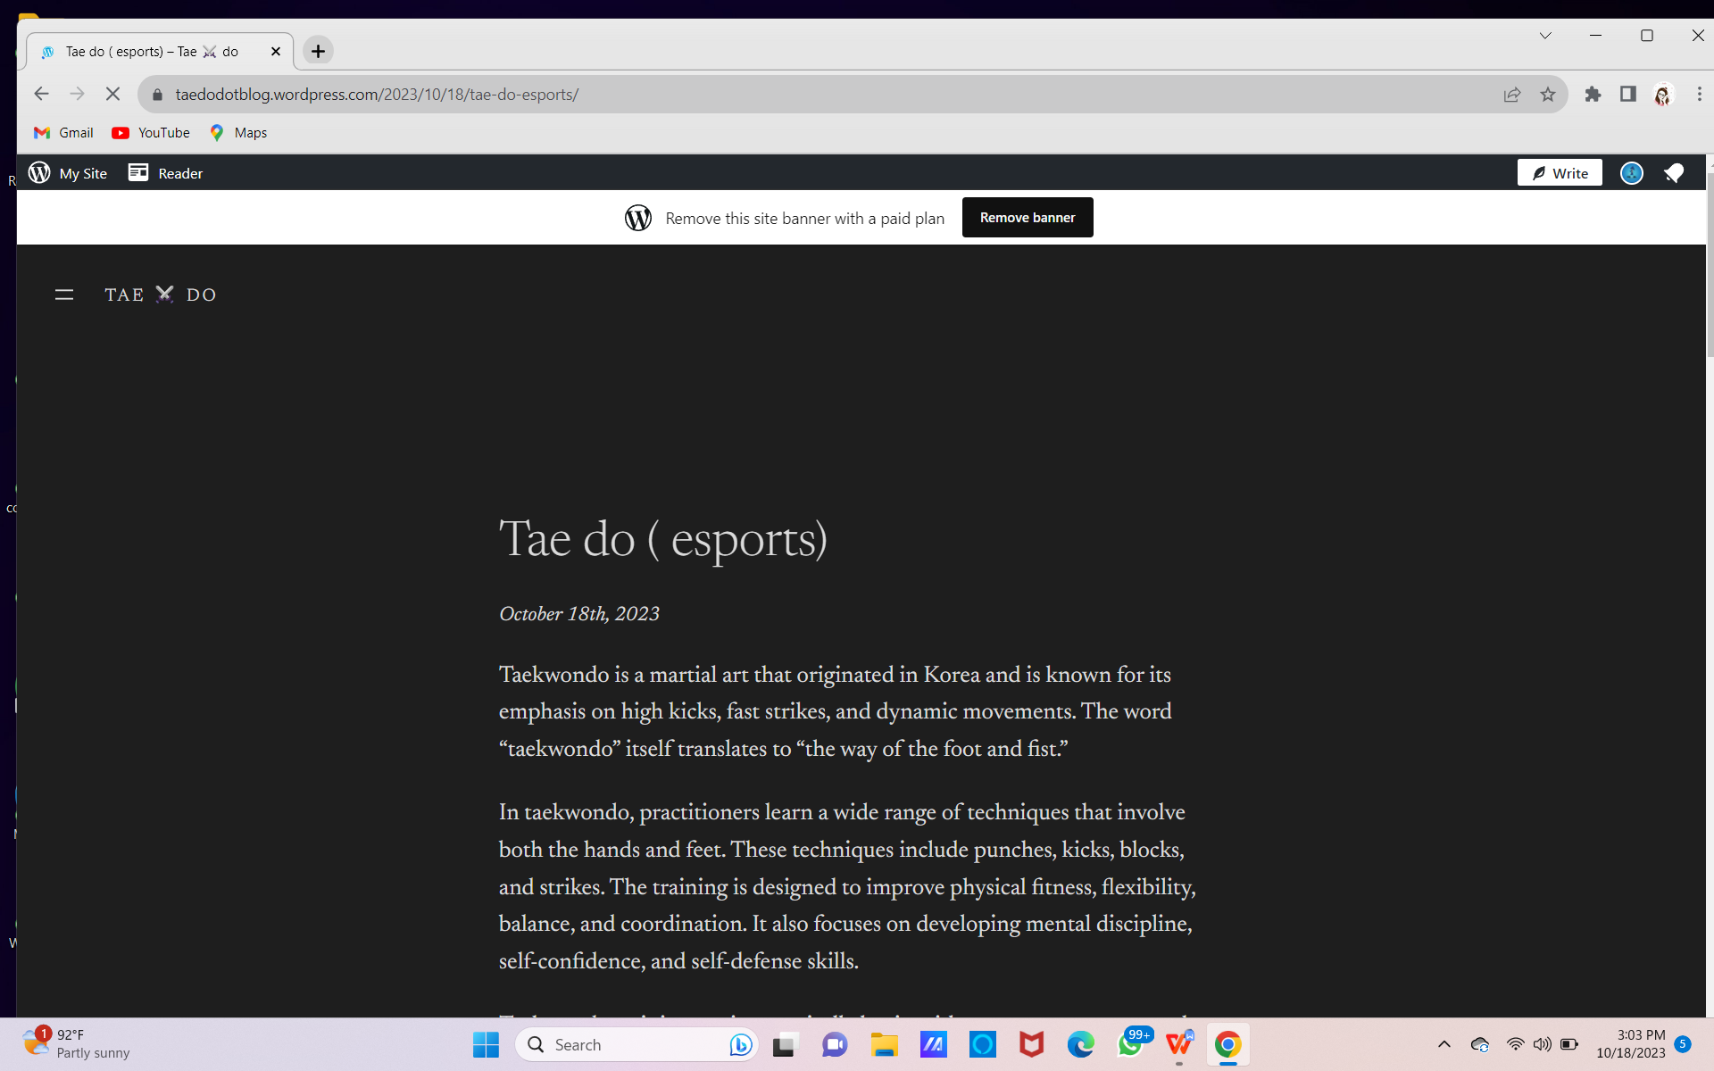

Blogpot:

<https://worldoftaekwond.blogspot.com/>

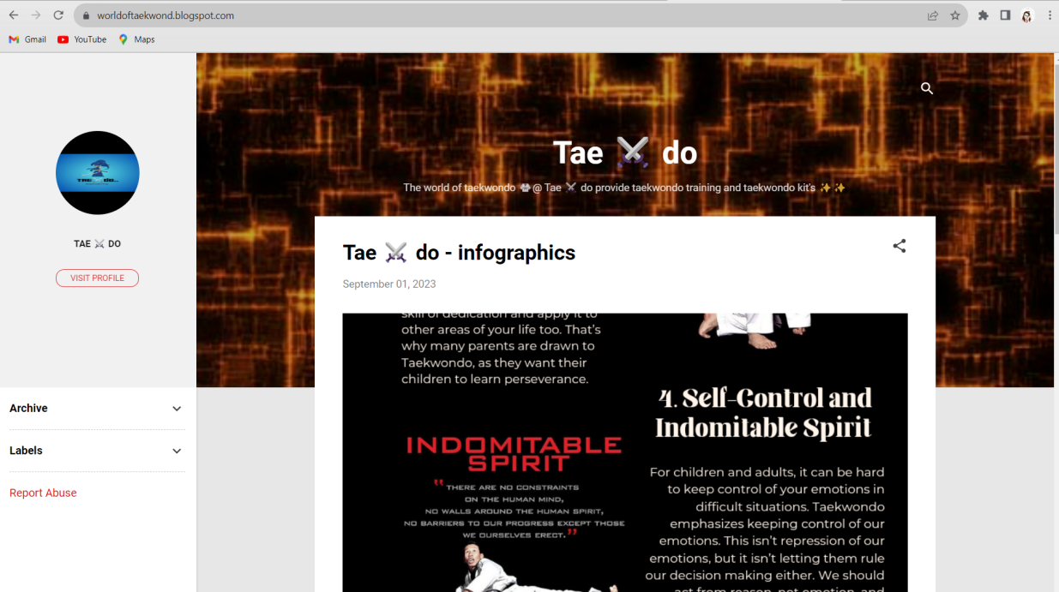

**ASSIGNMENT 2:**

Create a new Facebook business Page and Post one social media poster for your brand.

https://www.facebook.com/profile.php?id=61550324042394

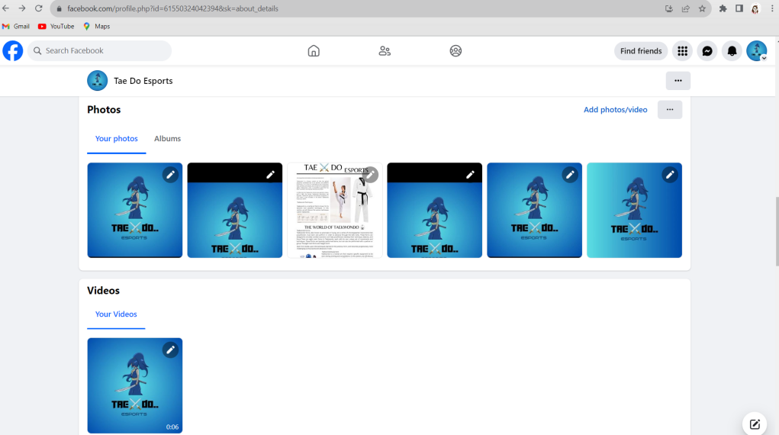

**ASSIGNMENT 3:**

Create and design a social media advertisement poster using Canva.



**ASSIGNMENT 4:**

Create email newsletter design using MailChimp or Canva tool.

